MICROCONTROLLER ASSIGNMENT 2

23. Write an ALP to generate a PWM signal of 25%, 50% and 75% duty cycle. Present the signal in the watch window of Keil IDE.

AREA PONN, CODE, READONLY

PWMMR1 EQU 0XE001401C

PWMLER EQU 0XE0014050

PINSEL0 EQU 0XE002C000

PWMPCR EQU 0XE001404C

PWMPR EQU 0X001400C

PWMMR0 EQU 0XE0014018

PWMMCR EQU 0XE0014014

PWMTCR EQU 0XE0014004

IO0DIR EQU 0XE0028008

IO0PIN EQU 0XE0028000

LDR R0, =PINSEL0

MOV R1, #0X02

STR R1, [R0]

LDR R0, =PWMPR

LDR R1, =0XBB7

STR R1,[R0]

LDR R0, =PWMMR0

LDR R1, =0X90000

STR R1, [R0]

LDR R0, =PWMMR1

MOV R1, #0x75000

;MOV R1, #(0XBB7 \* 75) / 100 ;

STR R1,[R0]

LDR R0, =PWMMCR

MOV R1, #0X02

STR R1,[R0]

LDR R0, =PWMLER

MOV R1, #0X03

STR R1,[R0]

LDR R0, =PWMPCR

MOV R1, #0X0200

STR R1,[R0]

LDR R0, =PWMTCR

MOV R1, #0X02

STR R1,[R0]

LDR R0, =PWMTCR

MOV R1, #0X09

STR R1,[R0]

START B START

END

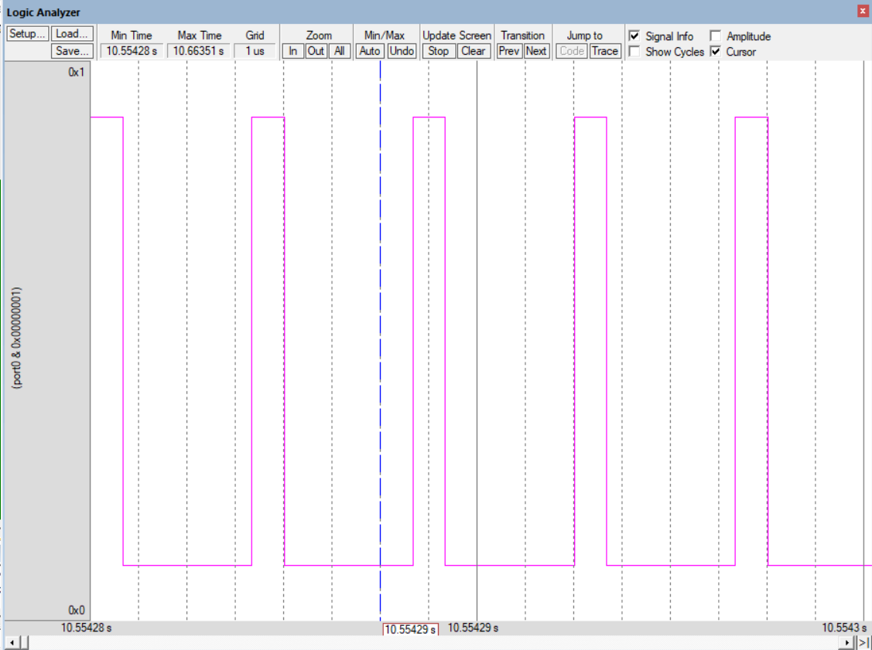

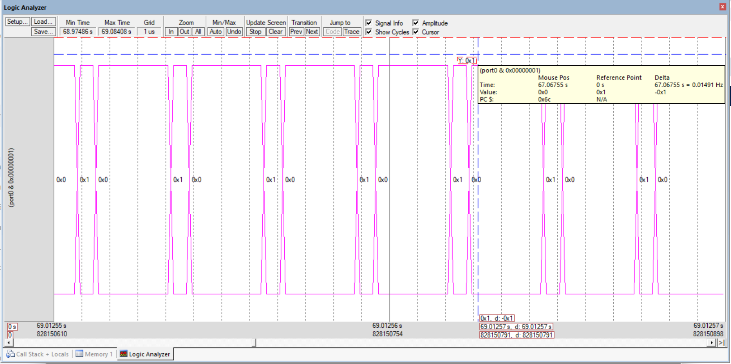24. Write an ALP to realize the following logic expression using LPC2148 constructs. RESULT = (AL’ or BL xor CL’) + ((Num1 \* Num2) + Num3).

AREA MyProgram, CODE, READONLY

; Define register usage

ENTRY

LDR R0, =AL ; Load operand A into R0

MVN R1, R0 ; Invert A (AL') and store in R1

LDR R2, =BL ; Load operand B into R2

EOR R3, R2, R1 ; XOR B with AL' and store in R3 (BL xor AL')

LDR R4, =Num1 ; Load operand Num1 into R4

LDR R5, =Num2 ; Load operand Num2 into R5

MUL R6, R4, R5 ; Multiply Num1 and Num2, store in R6 (Num1 \* Num2)

LDR R7, =Num3 ; Load operand Num3 into R7

ADD R6, R6, R7 ; Add Num3 to (Num1 \* Num2), store in R6 ((Num1 \* Num2) + Num3)

ORR R0, R3, R6 ; OR the result of (BL xor AL') with ((Num1 \* Num2) + Num3)

STR RESULT, =R0 ; Store the final result in the memory location 'RESULT'

START

B START ; Loop forever (optional, can be replaced with a program termination instruction)

END

23.. Write an LPC2148 ALP/C program to find the square root and cube root of a number.

AREA SQUARE,CODE,READONLY

ENTRY

LDR R0,=TABLE

LDR R1,=3

SUB R1,#1

ADD R0,R0,R1

LDRB R2,[R0]

STOP B STOP

TABLE DCB 01,04,06,09,16,25,49

END

